Be A Part of the Duck Fest Art Show!  We believe that art is a reflection of the creative spirit, and that each artist has a unique voice that should be heard. The Duck Fest Art Show will be held the second weekend in October, and we invite you to submit your art- be it paintings, sculpture, artisan crafts, ceramics, and photography! Show us your individual style and make DFAS the most talked about event of the season!

Open to all artists, of any age, using any subject or media.  Enter your works for display, and/or sale.

NO commission is taken on sold pieces, and monetary prizes will be given.

Name:

*Youth Entry for Merit Award (ages 10-15) *Age required:_____

*Note: Children under age of 10 are not eligible for Award but works will still be displayed

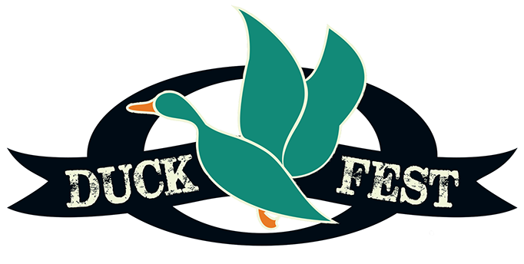Address:

City:                           State: Zip:

Phone: E-Mail:

Signature:

*Your signature indicates compliance with the regulations of the DuckFest Art Show.

ENTRY 1

Title:

Medium: For Sale?   Yes No     Price:

ENTRY 2

Title:

Medium: For Sale?   Yes No     Price:

ENTRY 3

Title:

Medium: For Sale?   Yes No     Price:

ENTRY 4

Title:

Medium: For Sale?   Yes No     Price:

ENTRY 5

Title:

Medium: For Sale?   Yes No     Price:

*Please include check paid to: Duck Fest Art Show Staff Use: PAID Check #

Return form to Amber Fortney, 227 Richard Ave W, Bowdon ND 58418

Like us on FB/ Duck Fest, or check out our website: www.bowdonnd.com/duck-fest for more information on the events for the weekend, or contact Amber Fortney: 701-412-1095 or at spunkyalexander@hotmail.com